Josh Peterson 01 Excel Homework

1. Given the provided data, what are three conclusions we can draw about Kickstarter campaigns?
   1. May/June/July have the highest levels of Kickstarter campaigns created.

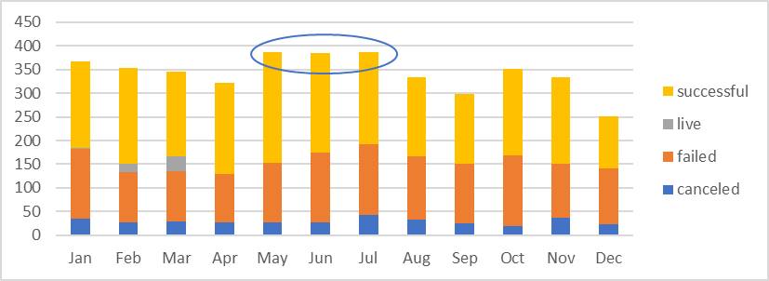

* 1. More campaigns are successful when submitted in May than in any other month.

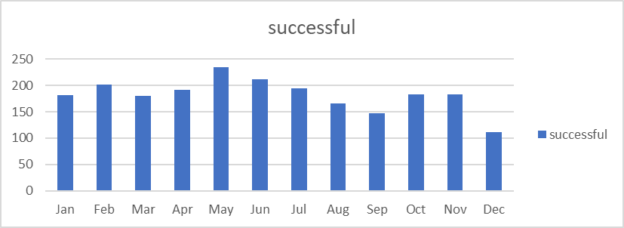

* 1. Food campaigns created in January have a high rate of failure.

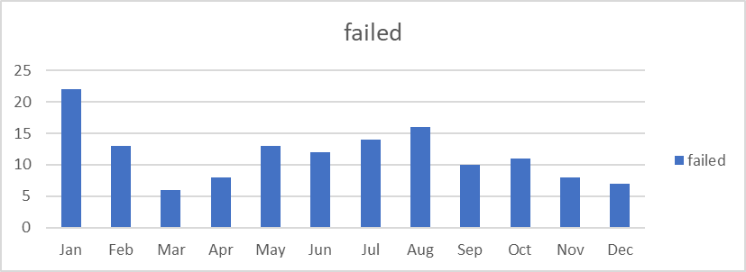

1. What are some limitations of this dataset?
   1. The data is shown in months, limiting the ability to track finer trends on a daily basis, or inter-month basis.
2. What are some other possible tables and/or graphs that we could create?
   1. We could look at state-specific trends, so for instance showing a bar chart of only successful campaigns, to identify when during the year (and which year) campaign launches are most successful.